Contents
Spring Core 2
1. What is Spring Framework? 2
2. Features of Spring Framework? 2
3. Explain Inversion of Control (IoC) and types of IoC containers. 4
4. Types of DI, when should we go for each DI? 5
5. Compare XML-based, annotation-based, and Java-based configuration. When would you use each? 7
6. Differentiate between constructor injection and setter injection 10
7. What are the different bean scopes in Spring? Explain each with examples 10
8. Explain the lifecycle of bean 13
9. What is lazy initialization in Spring? When and why would you use it? 15
10. Explain the different types of Autowiring 16
11. What is the use of @Qualifier annotation? Demonstrate it with an example 16
12. What is a circular dependency in Spring, and why does it occur? And how to solve it? 16
13. What is transitive dependency? 16
14. What is ApplicationContext and BeanFactory Container? 16
Spring Boot/Rest 18
1. What is Spring Boot Framework? 18
2. Spring Vs Spring Boot? 18
3. What is features of Spring Boot? 18
4. Explain the @SpringBootApplication annotation? 20
5. What is the role of the @RestController annotation in Spring Boot, and how does it differ from @Controller? 20
6. What is the API versioning? Is it possible in rest? How to do it? 20
7. What is hateoas in spring boot? 20
8. What is richardson maturity model? 21
9. Diff between rest and soap architecture. 23
10. What is path variable and request parameters? 23
11. What does @Value and @ConfigurationProperties annotation do? 24
12. How to handle the exception in rest api? 25
13. Tell me the name of some starter dependency in spring boot? 26
14. What is mean by path and classpath in java? 26
15. What is mean by API and REST API? 26
Spring Security 28

Spring Core

What is Spring Framework?
Spring framework is an open-source Java framework that supports building robust Java applications. It mainly handles all the infrastructure-related aspects allowing the developer to focus more on application development, making it the world's most popular Java framework.

Features of Spring Framework?
- Inversion of Control (IoC)
The most important feature of the Spring Core framework is Inversion of Control (IoC). Normally, objects create and manage their own dependencies using the new keyword, but in Spring, this responsibility is given to the IoC container. The container takes care of creating, configuring, and managing the lifecycle of objects, which are called beans in Spring. This approach inverts the control of object creation from the application code to the framework, hence the name “Inversion of Control.”
- Dependency Injection (DI)
Dependency Injection is a specific implementation of IoC where the container injects dependencies into a class rather than the class creating them itself. Spring supports multiple ways of dependency injection, such as constructor injection, setter injection, and field injection. This makes the application code more flexible, easier to test, and free from boilerplate object creation logic. For example, instead of a service class creating its own repository object, Spring automatically provides it at runtime.
- Loose Coupling
Spring promotes loose coupling between application components by encouraging code to depend on abstractions (interfaces) rather than concrete implementations. With DI, different implementations of a dependency can be injected into a class without modifying the class itself. This makes it easier to replace, extend, or test components. For instance, a payment service can work with a credit card processor today and a UPI processor tomorrow without changing its core logic.
- Aspect-Oriented Programming (AOP)
Aspect-Oriented Programming in Spring allows developers to separate cross-cutting concerns such as logging, security, or transaction management from the main business logic. Without AOP, such concerns would need to be duplicated across multiple methods, cluttering the code. With AOP, these concerns can be defined in separate classes called aspects and applied declaratively wherever needed. This keeps the business logic clean and focused while ensuring cross-cutting concerns are applied consistently across the application.
- Transaction Management
Spring provides a consistent and simplified approach to transaction management across different data access technologies such as JDBC, JPA, and Hibernate. Developers can manage transactions either programmatically or declaratively using annotations like @Transactional. The framework ensures proper commit or rollback of transactions in case of failures, thus maintaining data integrity. This eliminates the need for repetitive boilerplate code for transaction handling and makes applications more reliable.
- Bean Lifecycle Management
Spring manages the complete lifecycle of beans, from instantiation to initialization and eventual destruction. Developers can define custom initialization and destruction logic using annotations such as @PostConstruct and @PreDestroy or by implementing lifecycle interfaces. This makes it easier to manage resources such as database connections or file handles that require explicit setup and cleanup, ensuring better resource management within the application.
- Spring Expression Language (SpEL)
The Spring Expression Language (SpEL) allows injecting dynamic values into beans by evaluating expressions at runtime. It supports arithmetic operations, accessing system properties, calling bean methods, and conditional logic. For example:
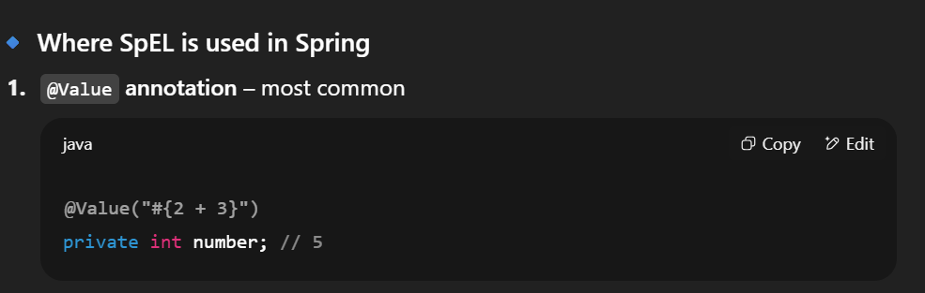
- Integration with Other Frameworks
Spring is designed to integrate seamlessly with other technologies and frameworks. It provides built-in support for working with data access frameworks such as JDBC, Hibernate, and JPA, messaging systems like JMS, and even modern tools like Kafka and RabbitMQ. Additionally, Spring integrates easily with web frameworks and cloud solutions, enabling developers to build end-to-end enterprise applications without worrying about compatibility or boilerplate integration code.

Explain Inversion of Control (IoC) and types of IoC containers.
IoC stands for Inversion of Control means transferring the control of managing the dependencies and their injection when required from the application to the container/framework, It increases code scalability, maintainability, and easy testing.
Types of IoC Containers:
- Bean Factory
- Application Context
Feature | BeanFactory | ApplicationContext
Definition | Fundamental container providing basic functionality for managing beans. | Advanced container extending BeanFactory with additional features.
Usage | Suitable for building standalone applications. | Suitable for building web applications, integrating with AOP modules, ORM, and distributed applications.
Bean Scopes Supported | Supports only Singleton and Prototype bean scopes. | Supports all types of bean scopes, including Singleton, Prototype, Request, Session, etc.
Annotation Support | Does not support annotations; requires configuration in XML files. | Supports annotation-based configuration for bean autowiring.
Internationalization | Does not provide internationalization (i18n) functionality. | Extends MessageSource interface to provide internationalization (i18n) functionality.
Event Handling | Does not support event publication. | Supports event handling via the ApplicationEvent class and ApplicationListener interface.
Initialization | Creates bean objects on demand using lazy initialization. | Loads all beans and creates objects at startup using eager initialization.
Resource Usage | Provides basic features requiring less memory, suitable for memory-critical standalone applications. | Provides basic and advanced features, suitable for enterprise applications, requiring more memory.

Types of DI, when should we go for each DI?
1. Constructor Injection
In constructor injection, the dependencies of a class are provided through its constructor. This ensures that the object is fully initialized with all required dependencies at the time of creation. It is the most recommended form of injection in Spring because it enforces immutability, makes dependencies explicit, and simplifies unit testing.
👉 When to use:
- When the dependency is mandatory
- When you want immutability (final fields)
- When you need better testability
- We don’t need to add @Autowired annotation if we constructor base DI
👉 Example:

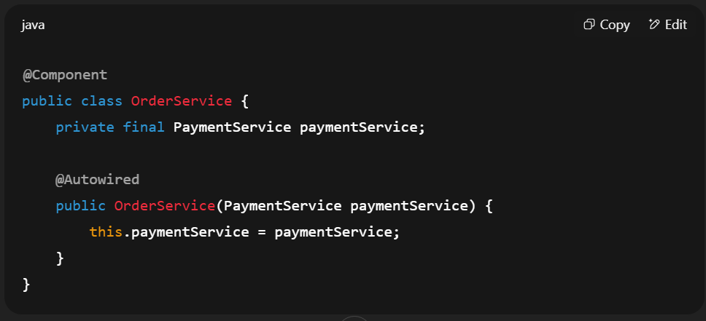

2. Setter Injection
In setter injection, dependencies are provided through setter methods after the object has already been created. This approach is more flexible because dependencies can be reconfigured or replaced later. Setter injection is best suited for optional dependencies or cases where a class can still function with default values.
👉 When to use:
- When the dependency is optional
- When dependencies may need to be changed later
- When you want to provide default values initially
👉 Example:
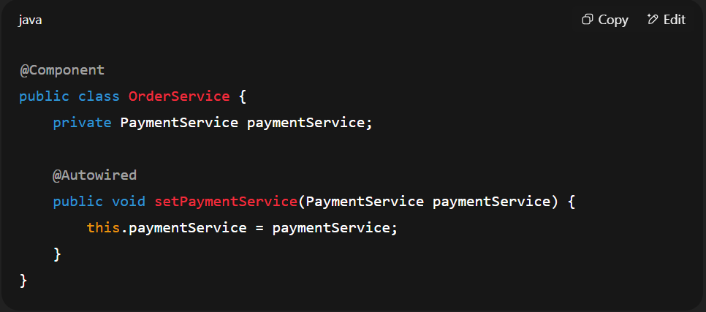

3. Field Injection
In field injection, dependencies are injected directly into class fields using annotations such as @Autowired. This method is very simple and concise, but it hides the actual dependencies, makes testing harder, and prevents immutability. It should generally be avoided in production but can be useful for smaller projects or quick prototypes.
👉 When to use:
- When building quick prototypes or demos
- When working on small-scale applications
- In legacy code where simplicity is preferred over testability
👉 Example:
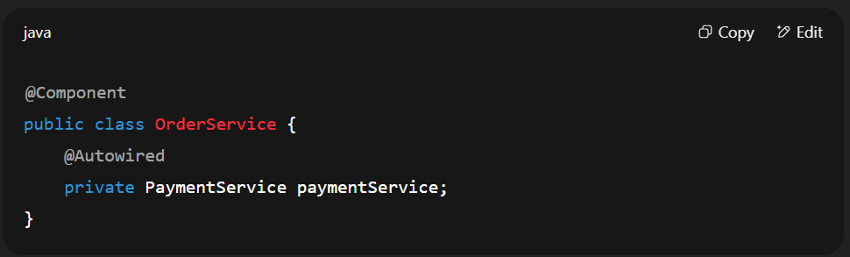
✅ Summary:
- Constructor Injection → Best for mandatory dependencies, immutability, and testing.
- Setter Injection → Best for optional or reconfigurable dependencies.
- Field Injection → Best for prototypes or quick solutions, not production.

Compare XML-based, annotation-based, and Java-based configuration. When would you use each?
1. XML-Based Configuration
In this approach, all beans and their dependencies are declared in an XML file (like applicationContext.xml). The container reads the XML to create and wire beans. It was the traditional way before annotations were introduced.
👉 When to use:
- Legacy projects where XML is already in place
- When configuration needs to be externalized (outside compiled code)
- For very large projects with centralized configuration files
👉 Example:
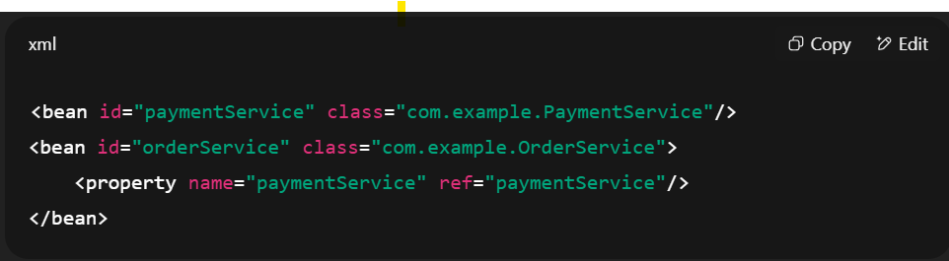

2. Annotation-Based Configuration
Here, beans are defined directly in Java classes using annotations like @Component, @Service, @Repository, and dependencies are injected with @Autowired. Spring automatically scans packages and registers beans. This reduces XML clutter and keeps configuration close to the code.
👉 When to use:
- Modern Spring projects (most common today)
- When you want less boilerplate and easy-to-read configuration
- Suitable for medium to large applications
👉 Example:
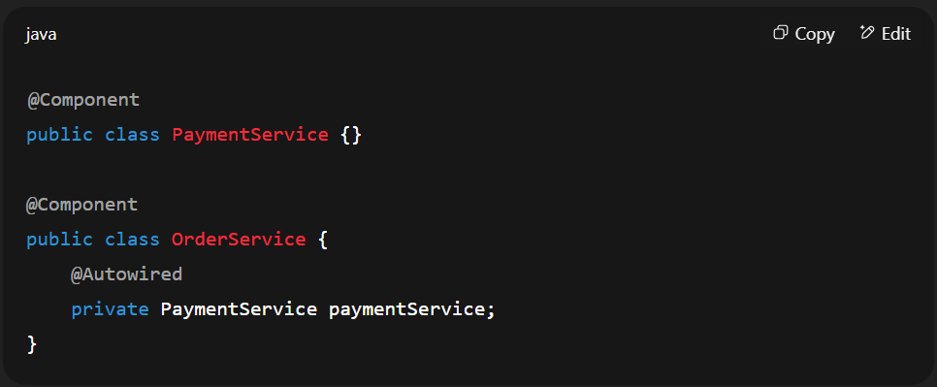
3. Java-Based Configuration
In this style, beans are defined in a @Configuration class with @Bean methods. It gives full control using pure Java code, type-safety, and IDE support (refactoring, auto-complete). This approach is considered the best practice in Spring Boot.
👉 When to use:
- Modern Spring applications (especially Spring Boot)
- When you want type safety and strong IDE support
- When configuration is complex and programmatic (e.g., conditionals, profiles)
👉 Example:
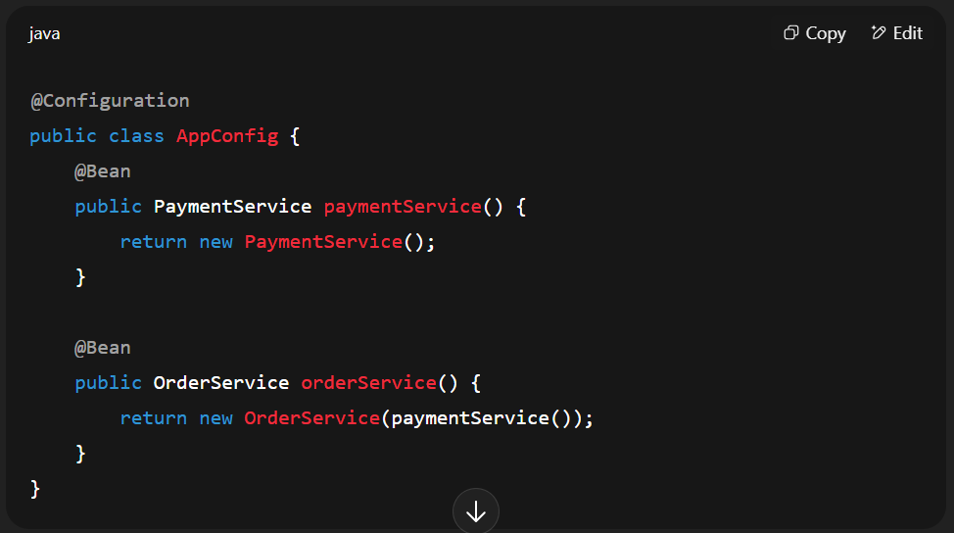
Summary Comparison
Approach | Pros | Cons | Best Use Case
XML-Based | Centralized, externalized | Verbose, not type-safe | Legacy apps, external config
Annotation-Based | Simple, less boilerplate | Somewhat tied to code | Most common today, medium apps
Java-Based | Type-safe, IDE-friendly, flexible | Slightly more verbose than annotations | Modern Spring Boot apps, complex configs

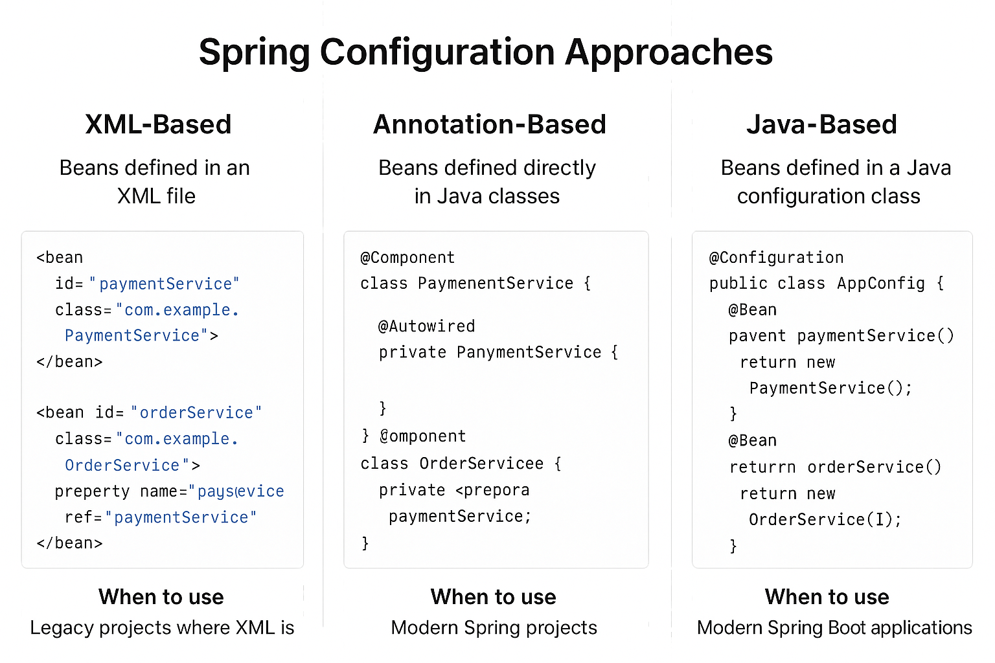

Differentiate between constructor injection and setter injection
Constructor Injection | Setter Injection
There is no partial injection. | There can be partial injection.
It doesn’t override the setter property. | It overrides the constructor property.
It will create a new instance if any modification is done. | It will not create new instance if any modification is done.
It works better for many properties. | It works better for few properties.

What are the different bean scopes in Spring? Explain each with examples
1. Singleton Scope (Default)
In Spring, the singleton scope is the default. Only one instance of the bean is created per Spring container, and the same instance is shared across all requests for that bean. The lifecycle begins when the Spring container starts, and the bean exists until the container shuts down. This scope is best suited for stateless services like service layer or repository beans because they don’t hold user-specific data. For example, a logging or payment service should ideally be a singleton.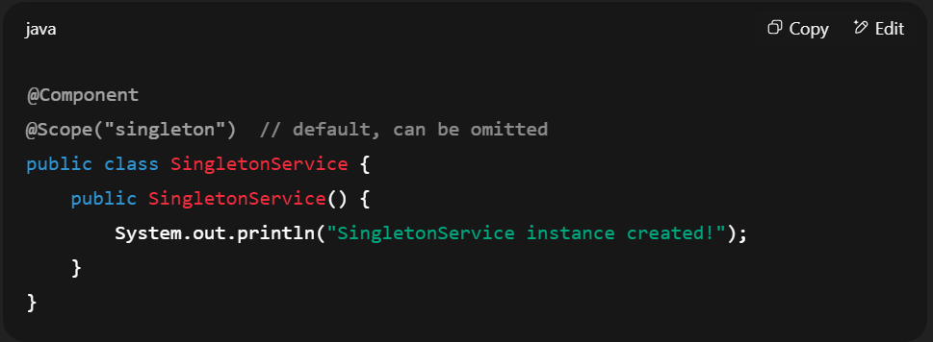

2. Prototype Scope
The prototype scope creates a new instance of the bean each time it is requested from the Spring container. Unlike singletons, the container does not manage the complete lifecycle of prototype beans—it only creates and returns a new instance, and the caller is responsible for destroying it. This is useful for stateful beans, where each client needs its own independent instance. For example, data transfer objects (DTOs) or objects holding temporary state can be declared as prototype beans.
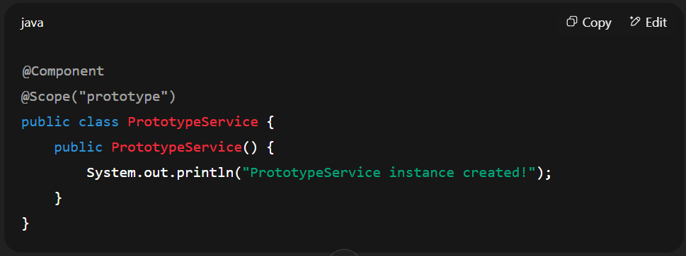
3. Request Scope (Web Only)
A request-scoped bean is created once per HTTP request and destroyed after the request is completed. This means that every HTTP request gets its own fresh instance of the bean, and it cannot be shared between multiple requests. This scope is typically used to store request-specific data, such as request parameters, headers, or temporary state needed only for that request. For example, a bean that captures request metadata for logging purposes can be request scoped.
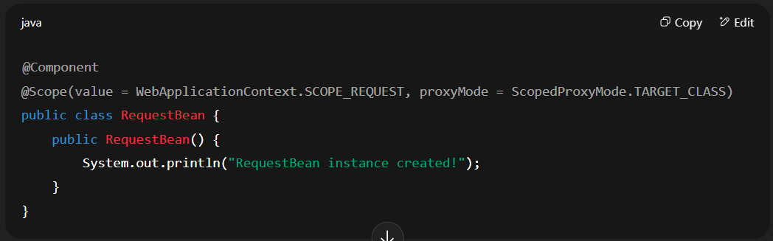
4. Session Scope (Web Only)
A session-scoped bean is created once per HTTP session and is shared across all requests that belong to the same user session. It is destroyed when the HTTP session is invalidated or times out. This scope is especially useful for user-specific data that must persist across multiple requests. For instance, user profile information, shopping carts, or authentication tokens can be stored in session-scoped beans.
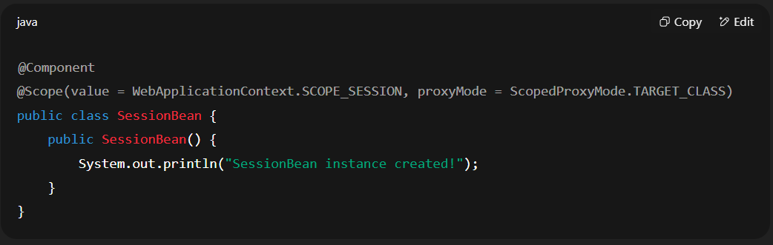
5. Application Scope (Web Only)
The application scope creates a single bean instance for the entire ServletContext (web application lifecycle). The bean is created when the web application starts and destroyed when the application is stopped (for example, when the server shuts down). This scope is used for global shared data, where the same bean must be accessed across the whole application, including multiple sessions and requests. A typical use case could be application-wide configuration or caching.
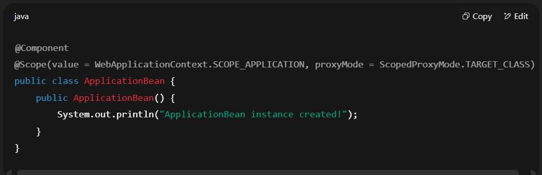

Explain the lifecycle of bean
Bean Lifecycle Flow (Step by Step)
- Instantiate → Object created.
- Populate Properties → Dependencies injected.
- Aware Interfaces → BeanNameAware, BeanFactoryAware, etc. called.
- Pre-Initialization → BeanPostProcessor. postProcessBeforeInitialization().
- Initialization → @PostConstruct, afterPropertiesSet(), init-method.
- Post-Initialization → BeanPostProcessor. postProcessAfterInitialization().
- Bean Ready → Used in application.
- Destruction → @PreDestroy, destroy (), destroy-method.

1. Instantiation (Object Creation)
The first step in a bean’s lifecycle is instantiation, where the Spring IoC container creates an object of the bean. This is typically done by calling the bean’s constructor or a static factory method defined in the configuration. At this stage, only the object itself is created, and no dependencies are injected yet
2. Dependency Injection (Populate Properties)
After the bean is created, Spring injects the required dependencies. This process is called Dependency Injection (DI), and it can be performed using constructor injection, setter injection, or field injection. With annotations like @Autowired, Spring automatically wires dependencies into the bean. At this point, the bean becomes fully populated with the resources it needs.
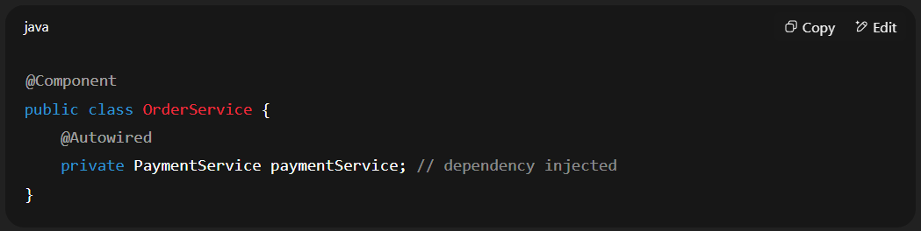
3. Aware Interfaces (Optional)
If the bean implements special aware interfaces, Spring provides contextual information about the bean. For example, BeanNameAware gives the bean its ID defined in the configuration, and BeanFactoryAware provides access to the factory that created the bean. This step is optional but allows beans to interact with the Spring container more directly.
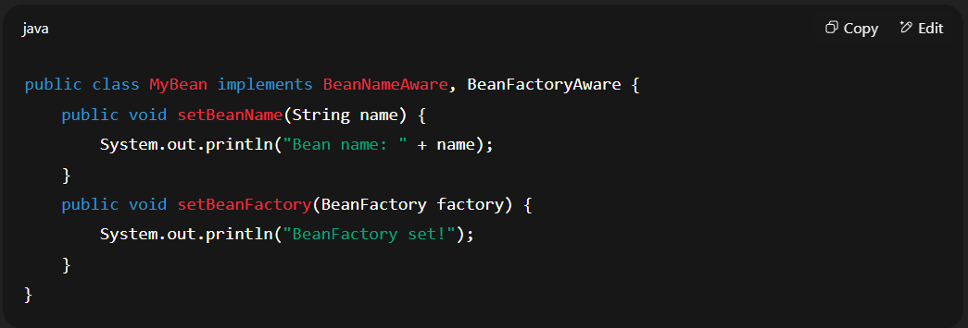
4. Initialization
Once the dependencies are injected and the aware interfaces are processed, the bean enters the initialization phase. Here, developers can run custom setup logic. Initialization can be done using @PostConstruct, by implementing the InitializingBean interface and overriding afterPropertiesSet(), or by specifying an init-method in the configuration. This phase is often used to open database connections, allocate resources, or load initial data.
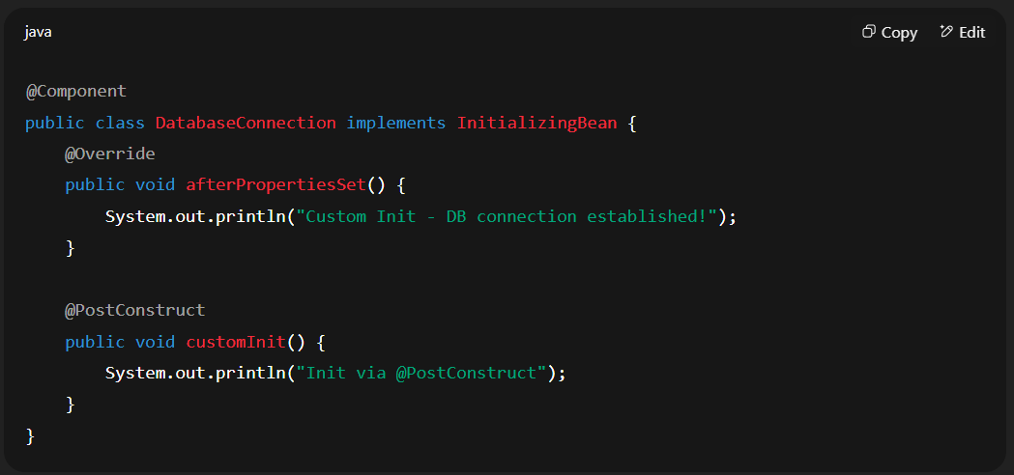

5. Post-Initialization (Bean Ready for Use)
After initialization, the bean is given a final opportunity to be customized using BeanPostProcessor. This is where proxy objects can be wrapped around beans, or cross-cutting concerns such as logging and security can be applied. Once post-initialization is complete, the bean is fully ready for use and can serve application requests.
6. Destruction (Cleanup Phase)
When the Spring container shuts down or the bean’s scope ends, the bean is destroyed. During this phase, Spring calls the destruction callbacks defined by the developer. This can be done using @PreDestroy, by implementing the DisposableBean interface and overriding the destroy() method, or by specifying a destroy-method in the configuration. This phase is used to release resources such as closing database connections, stopping background threads, or clearing caches.
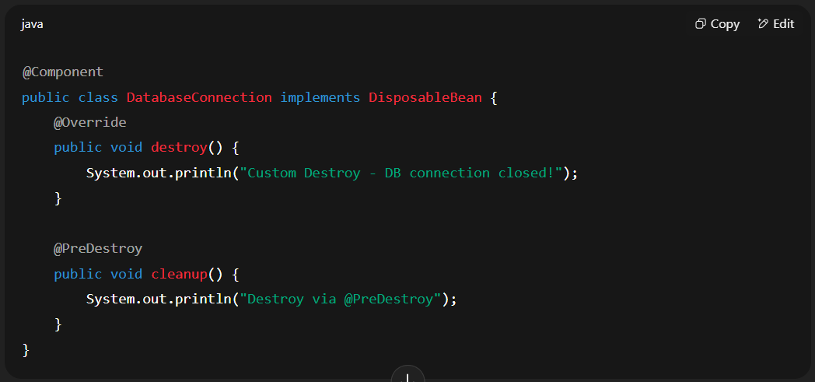

What is lazy initialization in Spring? When and why would you use it?
Lazy initialization means that a bean is not created until it is requested for the first time. It can be enabled using the @Lazy annotation. It is useful when a bean might be expensive to create or is not always needed.
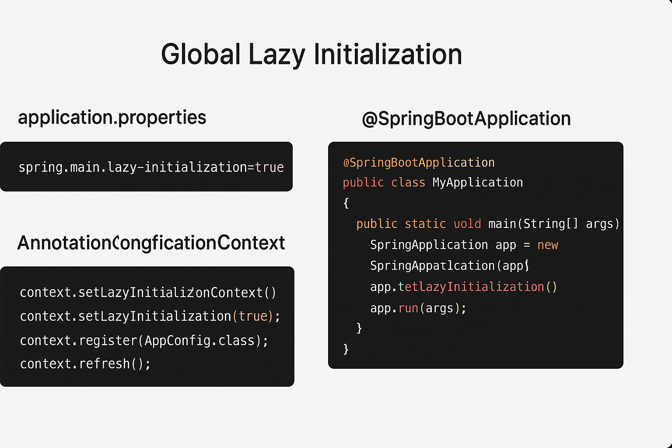

Explain the different types of Autowiring
Modes | Description
No | This mode tells the framework that autowiring is not supposed to be done. It is the default mode used by Spring.
byName | It uses the name of the bean for injecting dependencies.
byType | It injects the dependency according to the type of bean.
Constructor | It injects the required dependencies by invoking the constructor.
Autodetect | The autodetect mode uses two other modes for autowiring - constructor and byType.

Resources: https://dzone.com/articles/autowiring-in-spring

What is the use of @Qualifier annotation? Demonstrate it with an example
The @Qualifier annotation in Spring is used in conjunction with @Autowired to resolve ambiguity when multiple beans of the same type exist in the Spring IoC container. When Spring encounters multiple candidate beans for a single autowired dependency, it throws a NoUniqueBeanDefinitionException. @Qualifier provides a mechanism to explicitly specify which particular bean should be injected.
Resources: https://www.baeldung.com/spring-qualifier-annotation

What is a circular dependency in Spring, and why does it occur? And how to solve it?
Resource: https://www.baeldung.com/circular-dependencies-in-spring

What is transitive dependency?
A transitive dependency occurs when a bean depends on another bean, which in turn depends on a third bean, forming a chain of dependencies. For example, Bean A depends on Bean B, and Bean B depends on Bean C. Unlike a circular dependency, transitive dependencies do not form a cycle, so they do not cause errors related to circular references.

What is ApplicationContext and BeanFactory Container?
Feature | BeanFactory | ApplicationContext
Definition | Fundamental container providing basic functionality for managing beans. | Advanced container extending BeanFactory with additional features.
Usage | Suitable for building standalone applications. | Suitable for building web applications, integrating with AOP modules, ORM, and distributed applications.
Bean Scopes Supported | Supports only Singleton and Prototype bean scopes. | Supports all types of bean scopes, including Singleton, Prototype, Request, Session, etc.
Annotation Support | Does not support annotations; requires configuration in XML files. | Supports annotation-based configuration for bean autowiring.
Internationalization | Does not provide internationalization (i18n) functionality. | Extends MessageSource interface to provide internationalization (i18n) functionality.
Event Handling | Does not support event publication. | Supports event handling via the ApplicationEvent class and ApplicationListener interface.
Bean Post Processing | Requires manual registration of BeanPostProcessors and BeanFactoryPostProcessors. | Automatically registers BeanFactoryPostProcessor and BeanPostProcessor at startup.
Initialization | Creates bean objects on demand using lazy initialization. | Loads all beans and creates objects at startup using eager initialization.
Resource Usage | Provides basic features requiring less memory, suitable for memory-critical standalone applications. | Provides basic and advanced features, suitable for enterprise applications, requiring more memory.

Spring Boot/Rest

What is Spring Boot Framework?
Spring Boot is built on top of the Spring framework to create stand-alone RESTful web applications with very minimal configuration and there is no need of external servers to run the application because it has embedded servers like Tomcat and Jetty etc.
- Spring Boot framework is independent.
- It creates executable spring applications that are production-grade.

Spring Vs Spring Boot?
Spring | Spring Boot
Spring is an open-source lightweight framework widely used to develop enterprise applications. | Spring Boot is built on top of the conventional spring framework, widely used to develop REST APIs.
The most important feature of the Spring Framework is dependency injection. | The most important feature of the Spring Boot is Autoconfiguration.
It helps to create a loosely coupled application. | It helps to create a stand-alone application.
To run the Spring application, we need to set the server explicitly. | Spring Boot provides embedded servers such as Tomcat and Jetty etc.
To run the Spring application, a deployment descriptor is required. | There is no requirement for a deployment descriptor.
To create a Spring application, the developers write lots of code. | It reduces the lines of code.
It doesn't provide support for the in-memory database. | It provides support for the in-memory database such as H2.
Developers need to write boilerplate code for smaller tasks. | In Spring Boot, there is reduction in boilerplate code.
Developers have to define dependencies manually in the pom.xml file. | pom.xml file internally handles the required dependencies.

What is features of Spring Boot?
1. Auto-Configuration
One of the most powerful features of Spring Boot is auto-configuration. It automatically configures Spring components and third-party libraries based on the dependencies that exist in the project’s classpath. For example, if you add the spring-boot-starter-web dependency, Spring Boot configures an embedded web server (Tomcat by default), a DispatcherServlet, and JSON message converters without requiring you to define them manually. This eliminates the need for verbose XML configurations and allows developers to focus on business logic rather than setup.

2. Starter Dependencies
Spring Boot provides starter dependencies, which are a curated set of Maven or Gradle dependencies bundled together for a specific purpose. These starters remove the hassle of figuring out compatible versions of libraries. For example, if you want to build a REST API, adding spring-boot-starter-web will automatically bring in Spring MVC, Tomcat, and Jackson. Similarly, for database operations, spring-boot-starter-data-jpa bundles Hibernate, Spring Data JPA, and related dependencies. This helps avoid dependency conflicts and speeds up setup.
3. Embedded Servers
Traditionally, Java applications required deployment to external servers like Tomcat or Jetty. Spring Boot simplifies this by including embedded servers. When you package your Spring Boot application as a JAR file, it already contains an embedded server, which allows you to run the application directly using java -jar. By default, Spring Boot uses Tomcat, but you can easily switch to Jetty or Undertow. This feature makes deployment easier and ensures your application runs consistently across environments.
4. Production-Ready Features (Actuator)
Spring Boot includes Actuator, a module that provides production-ready features for monitoring and managing applications. Actuator exposes a number of endpoints such as /actuator/health for checking application health, /actuator/metrics for viewing performance statistics, and /actuator/info for displaying application-specific details. These endpoints can be integrated with monitoring tools like Prometheus, Grafana, or ELK Stack, making it easy to observe and manage applications in real-world environments.
5. Spring Boot CLI
Spring Boot comes with a Command Line Interface (CLI) that allows developers to write and run Spring applications using Groovy scripts. This feature is particularly useful for rapid prototyping, as you can write minimal code and run it without setting up a full project structure. For example, you can write a simple REST controller in a Groovy script and run it instantly using the CLI, which is great for testing ideas quickly.
6. Externalized Configuration
Spring Boot supports externalized configuration, meaning you can define configuration properties outside of your application code. This allows the same application to run in different environments (development, testing, production) with different configurations without modifying the code. Configuration can be provided through application.properties, application.yml, environment variables, command-line arguments, or even remote config servers. For example, you can use different database URLs for dev and prod environments without touching the code.
7. Spring Boot DevTools
To enhance developer productivity, Spring Boot provides DevTools. This module enables automatic application restarts whenever code changes, supports LiveReload for UI development, and disables caching for templates during development. These features save time for developers by providing faster feedback loops, making it easier to test changes immediately without manually restarting the server each time.
8. Opinionated Defaults
Spring Boot follows the principle of opinionated defaults, which means it provides sensible default configurations for common scenarios. For example, the default embedded server port is 8080, the default JSON library is Jackson, and the default logging framework is Logback. These defaults reduce boilerplate setup, but they are not restrictive developers can easily override them as needed. This balance of convention over configuration makes Spring Boot easy for beginners and flexible for experts.

9. Microservices Support
Spring Boot is widely used for building microservices. Its lightweight architecture, embedded servers, and quick setup make it ideal for creating independent, deployable services. When combined with Spring Cloud, it provides powerful features like service discovery (Eureka), centralized configuration (Spring Cloud Config), API gateways (Spring Cloud Gateway), and circuit breakers (Resilience4j). This makes it the preferred choice for cloud-native and distributed systems.
10. Security Integration
Spring Boot seamlessly integrates with Spring Security to provide authentication and authorization features. By adding spring-boot-starter-security, developers get sensible defaults like basic authentication and form-based login out of the box. It also supports modern security standards such as OAuth2, JWT, and LDAP integration. This allows developers to secure their applications quickly without writing extensive configuration code, while still providing the flexibility for customization.

Explain the @SpringBootApplication annotation?
Resources: https://www.naukri.com/code360/library/springbootapplication-annotation

What is the role of the @RestController annotation in Spring Boot, and how does it differ from @Controller?
The @RestController annotation is a specialized version of the @Controller annotation in Spring Boot. It is used to create RESTful web services and combines @Controller and @ResponseBody in one. This means that methods in a @RestController class are capable of handling HTTP requests and returning data directly to the client as JSON or XML, without the need to annotate each method with @ResponseBody.

What is the API versioning? Is it possible in rest? How to do it?
API versioning is a method to manage different versions of a REST API, allowing developers to introduce new features or changes without breaking existing client applications that rely on older versions; in Spring REST, it is absolutely possible to implement API versioning using various strategies like including the version number in the URL path, using query parameters, or custom HTTP headers, effectively managing different API versions for different clients depending on their needs.
There are several types of strategies to versioning REST API using Spring Boot.
- URI Path Versioning
- Query Parameters Versioning
- Custom Header Versioning
- Content Negotiation Versioning

What is hateoas in spring boot?
HATEOAS stands for Hypermedia as the Engine of Application State. It's a constraint of the REST architectural style that promotes a more self-descriptive and decoupled approach to building APIs.
In essence:
- Instead of hardcoding URLs in your client, HATEOAS-compliant APIs provide links within their responses, allowing clients to discover and navigate the API dynamically.
- These links guide the client on what actions can be performed on a resource, and how to perform them.

Benefits of using HATEOAS in Spring Boot:
Improved decoupling:
Clients don't need to know the exact structure of your API's URLs. They can simply follow the links provided in the responses.
Easier evolution of the API:
You can change the URLs of your API endpoints without breaking existing clients, as long as you maintain the links in the responses.
Self-descriptive responses:
The responses provide not just data, but also information about how to interact with that data.
How to implement HATEOAS in Spring Boot:
Spring HATEOAS library:
Spring Boot provides a library specifically for implementing HATEOAS, which makes it easy to add links to your API responses.
Representation models:
You can use classes like RepresentationModel and its subclasses (e.g., EntityModel) to wrap your data and add links.
Link builders:
The Link class and its builders allow you to create links with appropriate relations and URIs.

What is richardson maturity model?
The Richardson Maturity Model (RMM), proposed by Leonard Richardson, is a model used to assess the maturity of a RESTful API based on its implementation levels. It consists of four levels, each representing a stage of maturity in the design and implementation of RESTful principles. When it’s reach to level four which is level 3 then it can say it’s completely rest Api and other level are stepping stone to rich that level
Level 0
- It is also called as plain old xml
- Http is used only as transport protocol. Http is used for remote interaction.
- To get the data and post the data we send the request to the same URL, only post request may be used.
- Eg. To get the data
POST http://localhost:8080/customer
To post the data
POST http://localhost:8080/customer

Level 1
- In level 0, there was only 1 URI
- In level 1, each resource is mapped to specific URI
- For example. URI to get the product
http://localhost:8080/products
URI to get the specific product
http://localhost:8080/products/1
- Still only one end point is used to retrieve and creating the data

Level 2
- In level 2, correct http verb is used for each request
- For each of those request, correct http response code is provided
- Eg. Get
http://localhost:8080/customers/1
200 OK

Level 3
- At level 3, API supports hateoas
- Example
GET http://localhost:8080/customers
For this, the response that we get is
Customer JSON+Self- documenting hypermedia
- Help in self-documentation

Diff between rest and soap architecture.
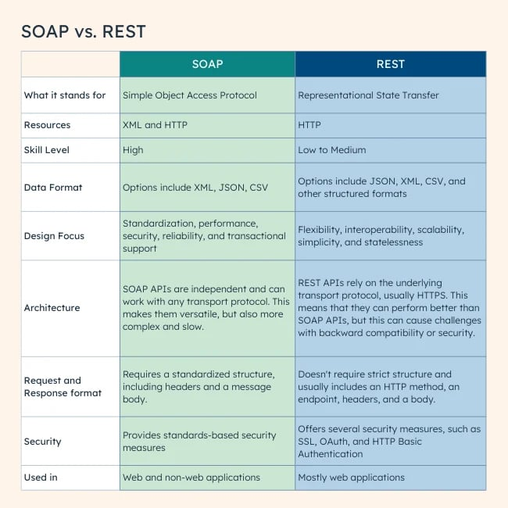

What is path variable and request parameters?
Path Variables
- Purpose: Used to capture dynamic elements within the URL path itself.
- Syntax: Defined within the URL path using curly braces {}.
- Example: /users/{userId}
- Access: Accessed using the @PathVariable annotation in controller methods.
- Required: Yes, by default.
- Use Case: Ideal for identifying specific resources in a RESTful API, like a user or a product.
@GetMapping("/users/{userId}")
public User getUser(@PathVariable Long userId) {
// ...
}

Request Parameters
- Purpose: Used to pass additional data to the server, typically for filtering, sorting, or pagination.
- Syntax: Appended to the URL after a question mark ?, in the format key=value. Multiple parameters are separated by ampersands &.
- Example: /users?page=2&size=10
- Access: Accessed using the @RequestParam annotation in controller methods.
- Required: No, by default. You can set the required attribute to true if needed.
- Use Case: Useful for providing optional parameters that modify the behavior of the request.
@GetMapping("/users")
public List<User> getUsers(@RequestParam(required = false) Integer page,
@RequestParam(required = false) Integer size) {
// ...
}

What does @Value and @ConfigurationProperties annotation do?
In Spring, both @Value and @ConfigurationProperties are used to inject values from external configuration sources (like application.properties or application.yml) into your Spring beans. However, they differ in their approach and capabilities:
@Value
- Purpose: Injects a single property value directly into a variable or method parameter.
- Syntax: @Value("${property.name}")
- Example
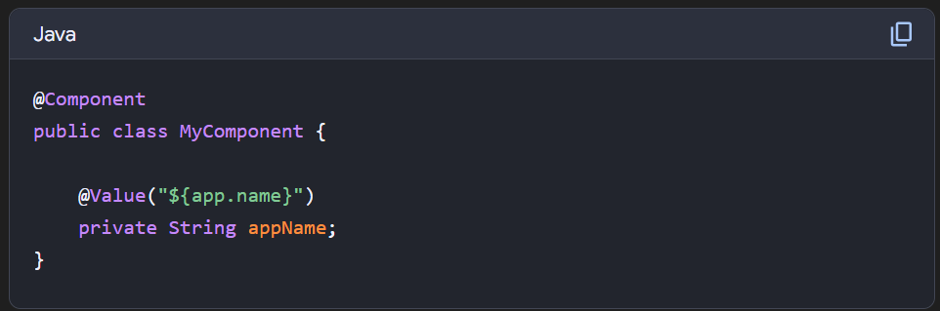

@ConfigurationProperties
- Purpose: Binds a group of related properties to a Java object.
- Syntax: @ConfigurationProperties(prefix = "prefix.for.properties")

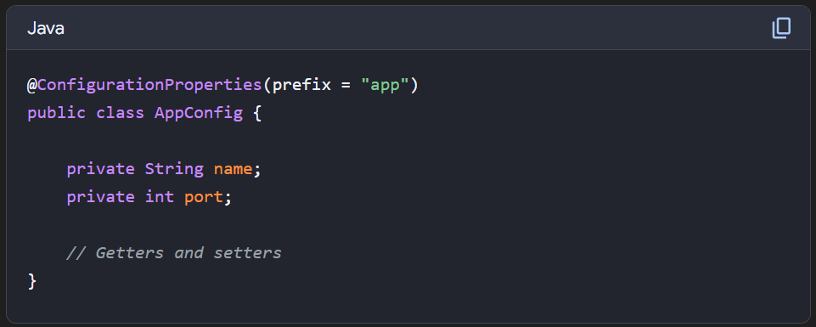

How to handle the exception in rest api?
Global Exception Handling with @ControllerAdvice
- @ControllerAdvice is a specialized annotation in Spring that allows you to handle exceptions globally across all controllers.
- You can create a class annotated with @ControllerAdvice to centralize your exception handling.

Custom Exception Classes
- Define custom exceptions for common issues like resource not found, bad requests, or unauthorized access.

Error Response Structure
- Create a custom error response class to ensure that error messages returned to the client are informative and standardized.

HTTP Status Codes and Detailed Messages
- Set appropriate HTTP status codes based on the type of error:
  - 404 for resource not found (HttpStatus.NOT_FOUND)
  - 400 for bad requests (HttpStatus.BAD_REQUEST)
  - 500 for internal server errors (HttpStatus.INTERNAL_SERVER_ERROR)
- Provide meaningful error messages to help the client understand the cause

Using @ResponseStatus
- Alternatively, annotate custom exception classes with @ResponseStatus to set a specific HTTP status code when the exception is thrown.

Tell me the name of some starter dependency in spring boot?
- spring-boot-starter-web: For building web applications with Spring MVC.
- spring-boot-starter-data-jpa: For working with JPA and databases.
- spring-boot-starter-security: For adding security features to your application.
- spring-boot-starter-test: For writing tests for your Spring Boot application.
- spring-boot-starter-actuator: For monitoring and managing your application.
- spring-boot-starter-thymeleaf: For using Thymeleaf as your templating engine.
- spring-boot-starter-mail: For sending emails from your application.
- spring-boot-starter-batch: For batch processing.
- spring-boot-starter-websocket: For building WebSocket applications.

What is mean by path and classpath in java?
Path
- The path variable tells the operating system where to find the executable files (like javac, java, javap, etc.) needed to run Java programs.
- It is set to the location of the Java Development Kit (JDK) binaries, like the bin directory where these executables reside.
- When you run a command like java or javac, the OS checks the path to locate these programs.
- Usage:
  - For example, in Windows, it might look like this: C:\Program Files\Java\jdk1.8.0_251\bin.
- Configuration:
  - To set the path, add the JDK bin directory to your OS’s path variable.
Classpath
- The classpath variable specifies the location of user-defined classes and packages, including external libraries (JAR files) that your Java programs need to run.
- It tells the Java compiler and runtime where to look for classes that are referenced in your code but are not in the same directory or JDK libraries.
- If you’re working with multiple external JARs or custom class files, you add them to the classpath.
- Usage:
  - For example, you might set the classpath like this: .;C:\libs\someLibrary.jar;C:\otherLibs\anotherLibrary.jar.

What is mean by API and REST API?
API
API stands for Application Programming Interface, and it's a set of rules that allows software applications to communicate with each other. APIs are the "interface" that enables one piece of software to interact with another program to obtain needed services.
REST API
REST API stands for REpresentational State Transfer API. It is a type of API (Application Programming Interface) that allows communication between different systems over the internet. REST APIs work by sending requests and receiving responses, typically in JSON format, between the client and server.
REST APIs use HTTP methods (such as GET, POST, PUT, DELETE) to define actions that can be performed on resources. These methods align with CRUD (Create, Read, Update, Delete) operations, which are used to manipulate resources over the web.
And it must follow the below 6 properties
- Uniform interface
- Client-server decoupling
- Statelessness
- Cacheability
- Layered system architecture
- Code on demand (optional)
Resource: https://www.ibm.com/think/topics/rest-apis

Spring Security

